
`

Microcontroller-Based Gaming console
Memory and Competitive Speed Game System
Computer programming for electronic engineers
(4FTC2029-0105-2025)

Youssef Hussien
Hamza Bassem
Mohammed Medhat
Zeyad Ala

April 29, 2026

Contents
- Introduction 3
- System Overview 3
  - Objectives . . . . . . . . . . . . . . . . . . . . . . . . . . . . . . . . . . . 3
  - System Architecture . . . . . . . . . . . . . . . . . . . . . . . . . . . . . 3
- Hardware Design
3.0 SIMULATIOUN ……………………………………………………………………………….. 4
  - Components Used . . . . . . . . . . . . . . . . . . . . . . . . . . . . . . . 5
  - Circuit Diagram . . . . . . . . . . . . . . . . . . . . . . . . . . . . . . . . 6
- Operational Modes 6
  - Solo Sprint . . . . . . . . . . . . . . . . . . . . . . . . . . . . . . . . . . . 6
  - Synchronous Duel . . . . . . . . . . . . . . . . . . . . . . . . . . . . . . . 6
  - The Challenger Mode . . . . . . . . . . . . . . . . . . . . . . . . . . . . . 7
  - VIDEO LINK ………………………………………………………………………………………………………………….. 7
- Software Design 8
  - State Machine . . . . . . . . . . . . . . . . . . . . . . . . . . . . . . . . . 8
  - Key Functionalities . . . . . . . . . . . . . . . . . . . . . . . . . . . . . . 8
- Data Management 8
  - Real-Time Display . . . . . . . . . . . . . . . . . . . . . . . . . . . . . . 8
  - Persistent Storage . . . . . . . . . . . . . . . . . . . . . . . . . . . . . . . 9
  - System Reset . . . . . . . . . . . . . . . . . . . . . . . . . . . . . . . . . 9
- Non-Functional Requirements…………………………………………………………………… 9
- Results…………………………………………………………………………………………………….. 10
- Conclusion……………………………………………………………………………………………….. 10
- Future Improvements………………………………………………………………………………. 10
- References……………………………………………………………………………………………………… 10
- Reference ……………………………………………………………………………………………………………..

Introduction
This project introduces a microcontroller-based gaming console created to test players’ memory and reaction speed. It features push-button input and output via LEDs, an LCD, and a buzzer, providing an engaging experience for one or two participants.
Enjoy solo matches or compete head-to-head, with every point tracked and high scores stored in non-volatile memory. The aim is a swift, user-friendly system, making embedded systems principles—like clever input handling and efficient coding—come alive.

System Overview

The microcontroller-based gaming console is a compact gaming device that uses Arduino as the main controller. The game is displayed on an LCD screen, while sound affects are produced using the MP3-TF-16P module with micro SD card.

The console is powered by a battery and controlled by a switch. LEDs, resistors and jumper wires are used to complete the circuit.

This project shows how simple electronic components can be used to create a fun and low-cost gaming console .

Objectives
The main objective is to develop a system capable of:
    - Managing multiple input buttons for two players.
    - Displaying sequences using LEDs.
    - Providing a responsive console.
    - Keep track of players score.

System Design
    - Input: 8 push buttons (4 per player)
    - Output: 4 LEDs + LCD display ₊ Speaker
    - Controller: Arduino Uno
    - Memory: MICRO SD for speaker
    - Speaker : using mp3-TF-16p

architecture.pn
Figure 1: System code

Hardware Design

3.0 simulation of circuit
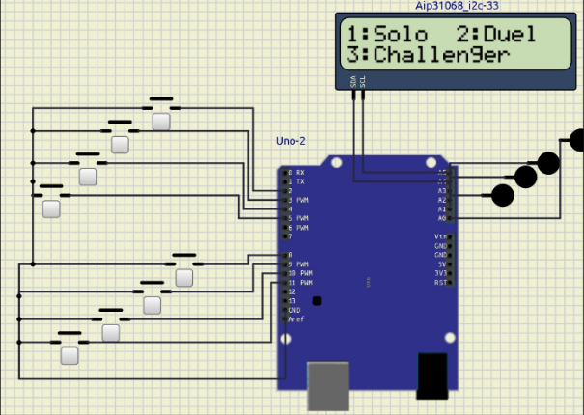
This circuit uses an Arduino Uno to control a simple user interface. Several push buttons are connected as inputs, allowing the user to select options. A LCD display (16x2) shows a menu (like “Solo,” “Duel,” and “Challenger”) using an I2C connection, while a few LEDs act as visual indicators. Overall, the Arduino reads the button presses and updates the display and LEDs based on the user’s choice.

Components Used AND COST
- Components | - Number of components | - Price
- Arduino UNO | - 1 | - 450
- MICRO SD | - 1 | - 355
- Jumpers 30 | - 2 packets | - 30
- MP3-TF-16P | - 1 | - 180
- Push Buttons | - 8 | - 520
- LEDs | - 4 | - 10
- LCD Display | - 1 | - 160
- Speaker | - 1 | - 30
- Battery | - 3 | - 250
- Battery holder | - 1 | - 80
- Resistors | - 4 | - 15
- Breadboard | - 1 | - 35
- switch | - 1 | - 50
3.2 CIRCUIT DIGARM
Arduino Uno connected to battery as power supply and LCD.
Circuit on breadboard with Arduino UNO, Push buttons, leds connected to laptop port as a prototype first.
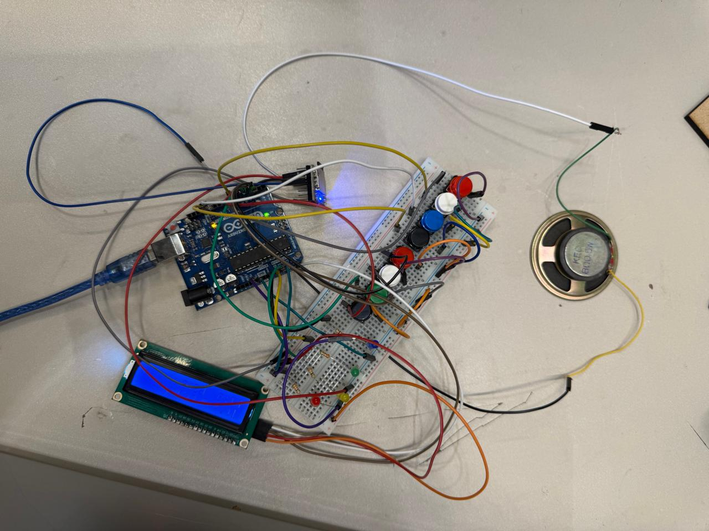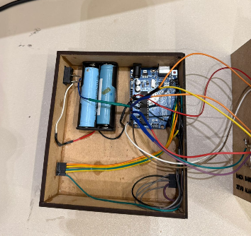
Figure 2: Circuit Diagram
- Operational modes

4.1 Solo Mode

This is a basic mode where the player interacts with the system individually. It is used for learning and becoming familiar with controls using buttons. The player has a LED pattern that they are required to replicate for 5 round each round is 15s. If player completes it correctly, the difficulty increses if not the difficulty returns to its original level.

Duo Mode
This mode has two players interacting with the system. It uses same LED pattern that both players are required to replicate. The player who replicates that pattern faster wins. If neither player is able to replicate it correctly , both lose. If one player makes a mistake, the system waits for the other player to complete the pattern. If player gets it correct, the difficulty level increases. The game consists of 5 rounds ,and each round has a total time of 15 seconds.

The Challenger Mode

This mode has the two players interacting with system. It uses the same LED concept. However, this time, one of the players inputs the LED sequence, and the other player has to replicate it correctly, if they are able to, they win. In contrast, if they fail to input the correct sequence, the player who first created the LED sequence has to input it correctly in order to win. Conversely, in the event they fail as well, they lose.

4.4 VIDEO LINK

https://drive.google.com/file/d/1lDrl-7GV8IcDV9j6TcR8_5u9JFI97C8c/view?usp=drivesdk

Software Design

State Machine
The system is implemented using a state machine with the following states:
    - Menu State
    - Playing State
    - Score Display State

MENU

THE CHALLENGER MODE
DUO MODE
SOLO MODE

SCORE DISPLAY STATE

Figure 3: State Machine Diagram

Key Functionalities
    - Difficulty scaling (faster LED timing)
    - Menu navigation via buttons
    - Audio feedback using speaker
    - Timeout detection (5 seconds)

Data Management

Real-Time Display
Scores for both players are continuously displayed on the LCD.

Volatile Storage
High scores are saved for a while until next games starts.

System Reset
When 5 rounds are finished score reset is done.

-Non-Functional Requirements
- Debouncing: handle timing and prevent false triggering.
- Power Efficiency: Sleep mode after a 5minutes.
- Modularity: Clean and maintainable code structure.
- Results
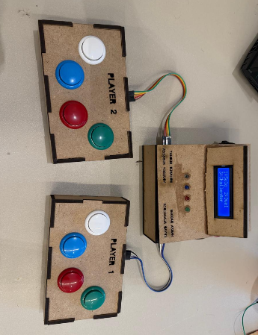

prototype.png

Figure 4: Final Prototype

9-DISCUSSION

The gaming console worked as it should and had modes with different levels of difficulty. The LED pattern modes were good for testing memory and reaction time, and the multiplayer modes made the game more fun and competitive. After adding code to stop input errors, the buttons worked better. There were some problems with timing and correctly detecting player actions, but these were fixed by testing and changing the code. In general, the console worked well and met the design needs.

10- Conclusion
The microcontroller-based gaming console we built is fun and interactive. It includes different modes, starting from practice and moving to more challenging LED pattern and competitive levels. The system uses lights and buttons to test reaction time and memory in a simple way. We also used the millis () function to ensure reliable button input. Overall, the console works as intended and provides an engaging gaming experience.

11 -Future Improvements
- Add menu navigation system
- Use real time clock
- Add a turn-based ranking system
- 3D printing controller while using better buttons.
Implement wireless which can be the 3rd player

12-References
- Tronicslk (2023) How to Use I2C LCD with Arduino | Very Easy Arduino LCD I2C Tutorial | Arduino 16x2 LCD I2C Tutorial. Available at: https://youtu.be/CvqHkXeXN3M
- DFRobot (2026) DFPlayer Mini Player Manual. Available at: https://wiki.dfrobot.com/DFPlayer_Mini_SKU_DFR0299

